**ADVISICON**

|  |
| --- |
| C:\Users\jon kangas\Pictures\OMI_color_logo_73pxX39px.gif  Technical Guide  Version 1.0  August 5, 2014 |
|  |

Table of Contents

[Purpose 2](#_Toc395002174)

[Design 2](#_Toc395002175)

[Development 2](#_Toc395002176)

[Overview 2](#_Toc395002177)

[Data Connections 2](#_Toc395002178)

[Deployment 4](#_Toc395002179)

[Updating Spreadsheet 4](#_Toc395002180)

[Set up “Advisicon Reports” Document Library 6](#_Toc395002181)

[Add and Configure Web Parts 9](#_Toc395002182)

[Verify Functionality 13](#_Toc395002183)

[Implementation/Configuration 13](#_Toc395002184)

[Document Search Web Part 13](#_Toc395002185)

[Troubleshooting 17](#_Toc395002186)

# Purpose

This document provides technical implementation of Project Issues and Status Excel Web Part.

# Design

The Risk and Issues Surfacer retrieves data already cached in the Project Center in the root of the PWA. This data is presented as a dashboard component rendered by the Excel Services Web Part.

# Development

## Overview

Initial development had called for workflows to populate a separate list in the Project Web App when items in the risks and issues lists were changed. According to this site <http://msdn.microsoft.com/en-us/library/office/ee767687(v=office.15).aspx> this is already performed for us. So development then changed to be centered on surfacing the data that was already cached by Project Server.

## Data Connections

Excel Services Pivot Tables gave us all the functionality (plus more) called for, and making the data connections from within the site was simplified because the Excel Services web part allowed for automatic user authentication.

Example: <https://advisicondemo2.sharepoint.com/sites/pwa/_api/ProjectData/Issues>

Available queries visible at <https://advisicondemo2.sharepoint.com/sites/pwa/_api/ProjectData/$metadata>

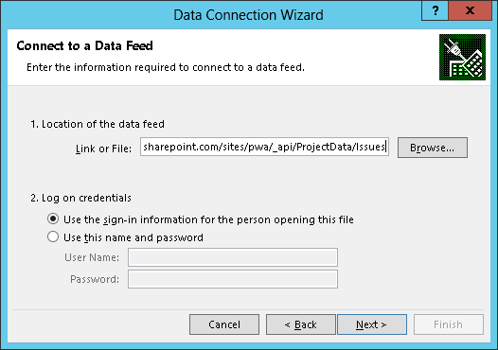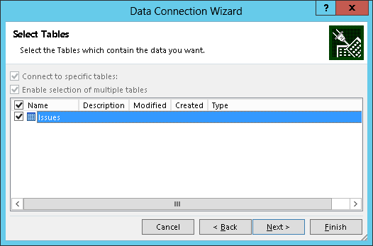

Excel 2013 allowed for combining multiple queries into a related dataset, giving us the ability to present the relationship between the Risks and Issues Data and the Project table. This is how we present all projects even when they do not have Risks or Issues associated with them.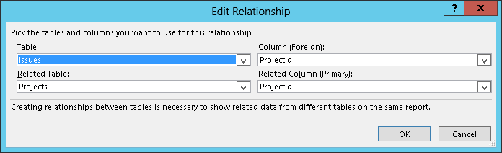

# Deployment

## Updating Spreadsheet

The Excel spreadsheet “Risk\_Issues\_RollUp.xlsx” need to be configured to draw data from the company’s project center.

**STEP 1:** Open the spreadsheet in Excel

**STEP 2:** Navigate to Data tab -> Connections group -> Connections

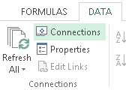

**STEP 3:** Configure the Properties for each connection: Risks, Issues, and Projects:

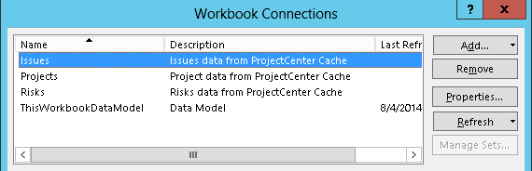

**STEP 3.1:** On the definition tab update the connection string:

Remove the 2 URLs: “<https://advisicondemo2.sharepoint.com/sites/pwa>” replacing them with the URL for the Project Web App ex: <https://ormutual.sharepoint.com/sites/pwa/>

**STEP 3.2:** Save changes by clicking “OK”

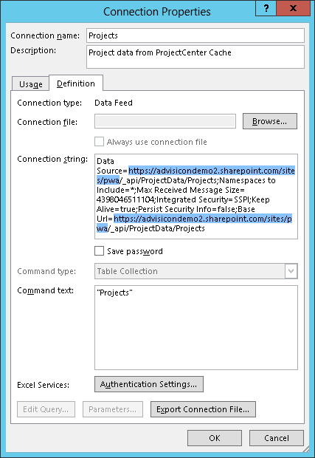

**STEP 3.3 – 3.6 Update each of the 3 connections in the same way: Issues, Risks, and Projects**

## Set up “Advisicon Reports” Document Library

On the website where you would like the dashboard

**STEP 1:** Gear -> Add and App

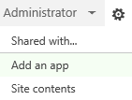

**STEP 1.1:** Click “Document Library”

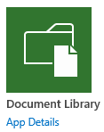

**STEP 1.2:** Click “Advanced Options” 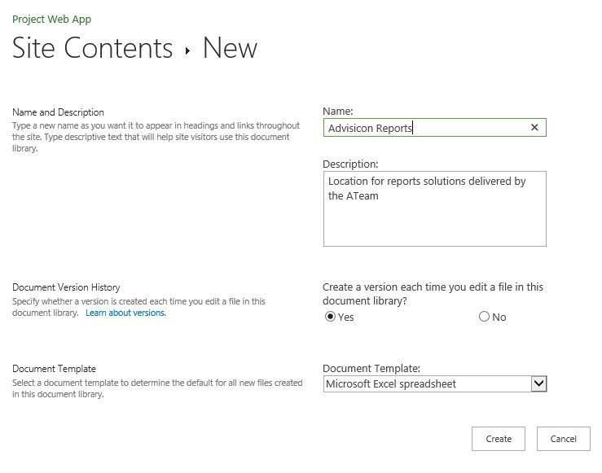

**STEP 1.3:** Name it “Advisicon Reports”

**STEP 1.4:** Give it a description

**STEP 1.5:** Create a version… Yes

**STEP 1.6:** Document Template: Microsoft Excel Spreadsheet

**STEP 2:** Upload the excel report “Risks\_Issues\_RollUp.xlsx” to the SharePoint library

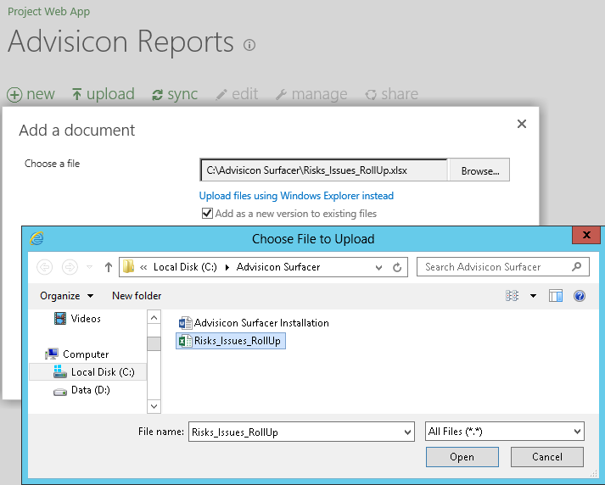

**STEP 3:** Test the refresh process to confirm the connections work:

**STEP 3.1:** Open excel document by clicking on the Name link.

**STEP 3.2:** If warned about the queries choose yes.

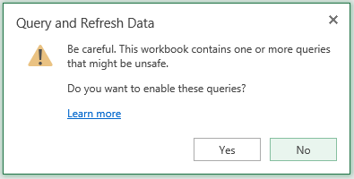

**STEP 3.3:** Right-click on the table and select refresh. 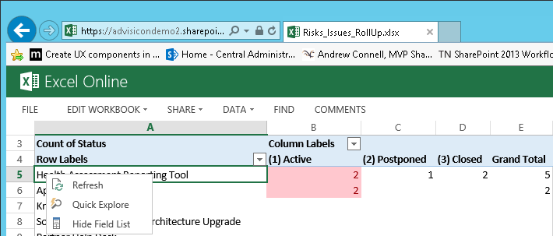

**STEP 3.4:** If asked whether you trust the document choose yes

**STEP 3.5:** If no errors, then query is working. If there are errors contact Advisicon to help edit the connection strings and/or verify permissions.

# Implementation/Configuration

## Add and Configure Web Parts

(Repeat this process once each for issues data and risks data)

**STEP 1:** Get URL for workbook

**STEP 1.1:** Go to Advisicon Reports library

**STEP 1.2:** Right click on the Name and choose “Copy Shortcut”

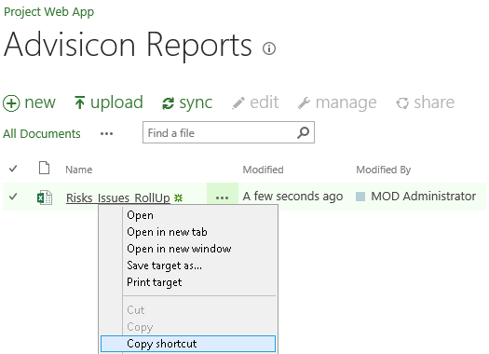

**STEP 2:** Add web part to the dashboard page.

**STEP 2.1:** Click on the Gear -> Edit Page

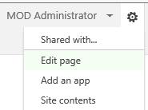

**STEP 2.2:** In the Area where you would like the list to appear, click on Add a Web Part

C:\Users\jon kangas\Pictures\AddWebPart.png

**STEP 2.3:** From the list of web parts choose Business Data -> Excel Web Access and click “Add”

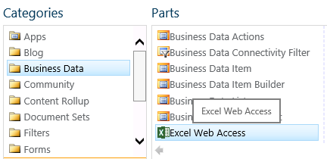

**STEP 3:** Configure the Web Part

**STEP 3.1:** In the top right-hand corner of the recently added web part click on the little down arrow and select “Edit Web Part”

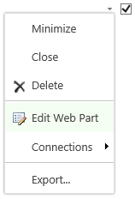

**STEP 3.2:** The Configuration Editor will open on the right.

**STEP 3.3:** Paste the URL copied in step 5.a.ii to the Workbook box

**STEP 3.4:** Set the named entry fields to RisksTable or IssuesTable to meet need.

**STEP 3.5:** Configure to remove all options to keep the dashboard looking right.

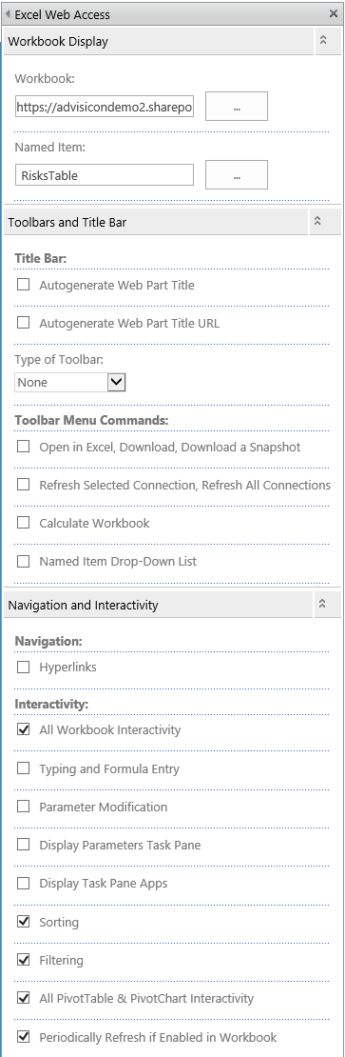

**STEP 3.6:** On the bottom click “OK”

**STEP 4:** When the page layout and lists look like you want click “Stop Editing”

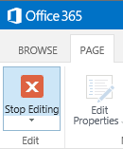

## Verify Functionality

**STEP 1:** Verify the spreadsheet refreshes when you go to the page

# C:\Users\jon kangas\Pictures\FinishedWebPart.png

# Troubleshooting